TRUST LOGO
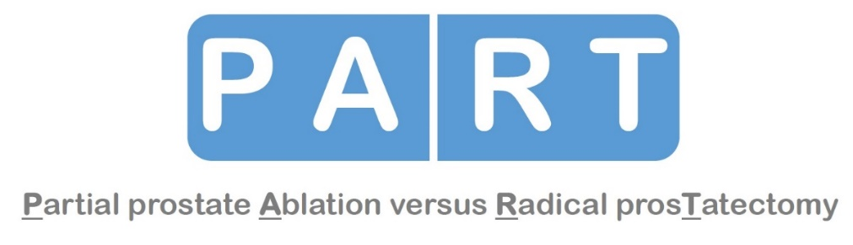

PATIENT INFORMATION LEAFLET

We would like to invite you to take part in a study called PART (Partial prostate Ablation versus Radical prosTatectomy). Before you decide whether you would like to join the study, it is important for you to understand why the research is being done and what it will involve. We will go through this patient information leaflet with you and answer any questions you might have. You can also talk to anyone else (e.g. family or GP) about your decision whether or not to take part. You do not have to decide straight away.

What is the purpose of the PART study?
You have been diagnosed with intermediate risk, localised prostate cancer on one side of the prostate gland only. Your doctor has discussed your treatment options with you and it has been agreed that you would normally be a suitable candidate for radical prostatectomy surgery. Sometimes however, the disease affects only one part of the prostate, and it may be better to treat only the affected area, rather than the whole gland by using a treatment called partial ablation. This may reduce the side-effects of radical treatments. This is what we are testing in the PART study. Partial ablation is not commonly used in the NHS but has previously been studied in other experimental areas. The procedures relating to this treatment have been widely used in other contexts. We are now trying to find out whether partial ablation can replace total gland treatment safely and effectively.

PART aims to find the best treatment for the type of prostate cancer you have. We are comparing surgery (radical prostatectomy) and partial ablation (High Intensity Focused Ultrasound) in terms of treating the cancer, quality of life (such as sexual, urinary and renal function) and the cost of treatment. There will be two stages to the PART study: Stage 1 where we aim to recruit 100 patients (to make sure that a bigger study can be conducted comparing these treatments) and Stage 2, where we aim to recruit a further 600-800 patients. Your doctor or research nurse will let you know which stage of the study we are now in. If you take part in Stage 1 your results and data will still be included in the same way as those patients in Stage 2.

What Is the prostate?
The prostate is an organ that forms part of the male reproductive system. It is located immediately below the bladder, just in front of the bowel. Its main function is to produce fluid that makes up part of the semen and may help enrich sperm. In younger men the prostate is about the size of a walnut. It is doughnut shaped as it surrounds the beginning of the urethra, the tube that conveys urine from the bladder to the penis. The nerves that control erections surround the prostate. A diagram of the location of the prostate is overleaf.
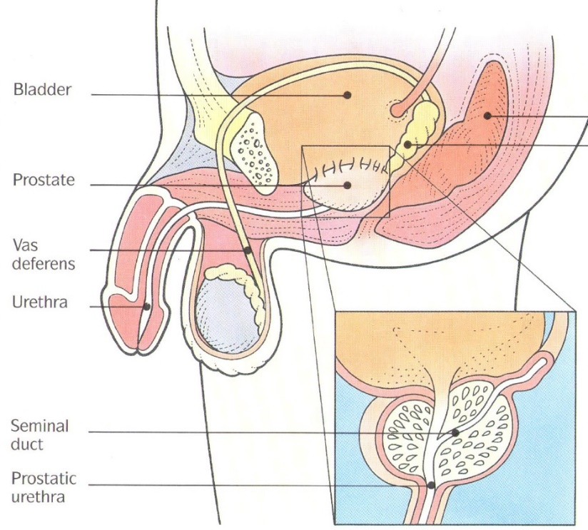
Figure 1: Location of the prostate

Why have I been asked to join the PART study?
You have been asked to consider joining the study because you have had a diagnosis of intermediate risk, localised prostate cancer on one side of the prostate gland only. Looking at your results, the research team think that you may be suitable for either partial ablation of the prostate to kill cancer cells, or surgery to remove the whole prostate.

Do I have to take part?
No. It is completely up to you to decide whether or not to join the PART study. If you decide to take part, you are still free to withdraw at any time without giving a reason. Whether you take part or not will not affect the standard of care you receive.

What will happen to me if I decide to take part?
In this study, we need to compare people who have partial ablation with those who have surgery. You will be given this information leaflet about PART when you visit your doctor at your routine clinic visit. You can take the information leaflet away with you, to think more about joining the study.

If after routine blood tests, MRI imaging and prostate biopsies, you are considered eligible to take part in the study, you will be invited to attend an information appointment to discuss the PART study further. We have summarised what taking part in this study would involve on page 7. If you are not eligible for the PART study, you will be informed by your doctor, who will go through your treatment options with you.

Partial Ablation
Partial ablation works by using sound waves (high-intensity focused ultrasound) to heat small areas of tissue where the cancer has been located. It is a day procedure and does not involve cuts or needles. The procedure is performed under general anaesthetic. The treatment involves a probe which will be introduced in your rectum, similar to the one you have experienced during your prostate biopsies. Since you will be under the general anaesthetic, you should not feel anything. The treatment lasts between 1-2 hours. Before starting the treatment, a tube is placed in your bladder through the skin at the bottom of your belly. This will be secured in place with a small stitch, and removed approximately 2 weeks after the treatment when we are happy that you can pass your urine well. The advantages and disadvantages of ablative therapy are included in the table on page 8.

Surgery
In most cases, this operation is now performed using robot-assisted keyhole surgery, under general anaesthetic. The instruments are inserted through six small holes in the belly and controlled by the surgeon from a remote console in the operating theatre, with the assistant at the operating table. Sometimes it is not possible to use keyhole surgery, and the surgeon has to perform an ‘open’ procedure. In this case, the surgeon will make a cut at the bottom of your belly. The advantages and disadvantages of robotic and open surgery are included in the table on page 8.

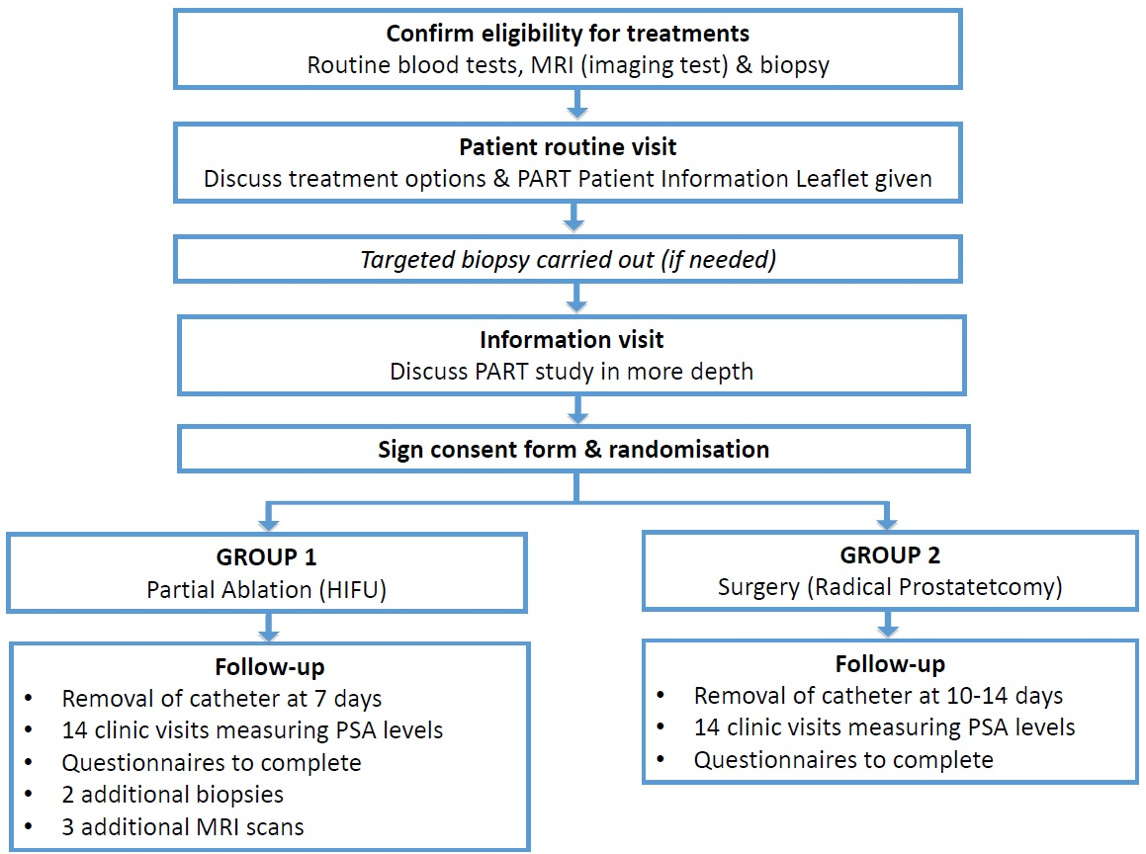
Figure 1: Diagram of the PART study

treatment allocation
The best way to compare these two treatments is to have similar groups of patients allocated to either ablative therapy or surgery in a research study. The only way to make sure that the groups of patients are as similar as possible is to have the allocation decided by chance: a process called randomisation. This means that you will have an equal chance of having either ablative therapy or surgery. This process ensures that the treatments are compared fairly. It is important for the study that you only agree to take part if you believe you would be prepared to accept either treatment. Whichever treatment you are allocated to, you will be treated with the best possible care and the surgeon treating you will be experienced in the technique.

consent & randomisation
During Stage 1 of the PART study, we will ask you if we can tape-record your information visit with your doctor and research nurse. This will help us to make sure that you are provided with enough information about the treatments and the study. We will ask you for written permission before this happens. Your appointment will go ahead, whether or not you agree to it being tape recorded. Some people will also be invited to be interviewed by one of our researchers in more detail about their experiences. This will only happen if you are willing to do this and after you provide written permission.

If after your information visit you decide to take part, you will be given this information leaflet to keep and asked to sign the PART study consent form. You will then be entered into the PART study and the research nurse or your doctor will tell you which treatment you have been assigned to straight away. The operation will then be within eight weeks from when you consented to join the study.

What happens if I want to choose which treatment I get?
At the end of the discussion, you may feel that you want to choose your treatment. However, you would not be able to select HIFU, because it is not yet a standard NHS treatment, which is the reason for conducting this study.

What happens during follow up?
Whatever group you are in, you will be under the care of your Consultant Surgeon and followed up regularly. As part of the study you will be asked to complete several questionnaires over the course of the 36 month duration. Table 1 on page 7 gives an overview of what information we would like to collect about you and when.

What if the cancer spreads or comes back?
You will be monitored carefully by the medical and research team, but you should always contact your GP or a member of the study team if you have any concerns. If your PSA blood test results suggests that your disease might have got worse, the doctors will organise new tests, x-rays or scans as they think are needed to assess things further. If you received HIFU and the biopsies (samples) show that you have new disease, on the other side of your prostate, we would offer you additional HIFU treatment.
If however there is persistent disease after either treatment (i.e. the cancer that you had at the start that was treated has returned), we will consider that the treatment has failed, and we would discuss with you your treatment options. These may include surgery, hormone therapy and/ or radiotherapy.

What are the potential benefits of taking part?
We cannot guarantee that participating in this study will be of direct benefit to you. The main benefit of you taking part will be the information that we can gather. This would help us improve treatment options for men with prostate cancer like you in the future.
What are the possible disadvantages and risks in taking part?
The risks for each treatment are listed in Table 2. Please read through them carefully, and ask as many questions as you wish at your next appointment.

What if something goes wrong?
The University of Oxford, as Sponsor, has appropriate insurance in place in the unlikely event that you suffer any harm as a direct consequence of your participation in this trial. If you wish to complain about any aspect of the way in which you have been approached or treated during the course of this study, you should contact the Chief Investigator Professor Hamdy on 01865 737 961 or part@nds.ox.ac.ukor you may contact the University of Oxford Clinical Trials and Research Governance (CTRG) office on 01865 572224 or the head of CTRG, email ctrg@admin.ox.ac.uk.

Will my participation in the study be kept confidential?
Yes. All information which is collected about you during the course of the research will be kept strictly confidential. You will be assigned a code number to ensure that you will not be identified in any way in any report arising from the study. As it is standard practice to inform your GP about your participation in a research study, we will ask your permission to do this.

Who is organising and funding the study?
PART is funded by the Health Technology Assessment Programme of the National Institute for Health Research, study number 12/35/54. The study is conducted by the University of Oxford. The researchers include a team of specialised doctors, scientists, technical staff and nurses. Our team is experienced and has conducted similar research in the field.

Who has reviewed the study?
This study was given a favourable ethical opinion for conduct in the NHS by the South Central - Berkshire Ethics Committee. This committee is responsible for making sure that research takes place in a way that protects the patients’ rights and welfare.

expenses and payments
Reasonable travel expenses for any visits additional to normal care will be reimbursed on production of receipts, or mileage allowance provided as appropriate.

Trial Results
When the study results are concluded, they will be presented by clinicians and patient groups, and posted on our website for patient to access. Our website is: http://part.octru.ox.ac.uk/

What do I have to do now?
You will be given as much time as you feel you need to discuss any issues or questions involving this research during your appointment with the researchers and study nurses. If you have any concerns or wish to discuss the study further, please contact:

[XXX – Local Research Nurse, address, tel number]

[XXX, Local Investigator, address, phone number]

Professor Freddie Hamdy, Study Chief Investigator
Nuffield Department of Surgical Sciences
University of Oxford
Old Road Campus Research Building (off Roosevelt Drive)
Headington, Oxford
OX3 7DQ
Tel: 01865 617 123

Steffi le Conte, Trial Manager
Botnar Research Centre
Surgical Intervention Trials Unit (SITU)
Windmill Road, Headington
Oxford, OX3 7LD
Tel: 01865 737 961
Email: part@nds.ox.ac.uk

Thank you for taking the time to read this information sheet.

Table 1: overview of required information and timings

Time | Place | Activity/Information collected
Joining the PART study (consent and treatment allocation) | Outpatient department | - Routine blood tests will be taken to record how well your kidneys work and what you blood is made of (a full blood count)  - Review of your medical history  - Physical examination, including a rectal examination by a doctor  - A repeat Prostate Specific Antigen (PSA) test  - Questionnaires: questions relating to your sexual activity, general health and recovery goals.  - A check of your fitness to have a general anaesthetic  - Randomisation – the research team will let then you know which treatment group you have been allocated to
Study treatment for your prostate cancer (this will ideally be within  8 weeks from being consented) | Inpatient Department | - If allocated to partial ablation:  - You will have to wait at least 6 weeks following any biopsy that was taken in getting to your diagnosis to allow swelling and inflammation to settle in the prostate. You will then receive the partial ablation.  - If allocated to surgery:  - You will be listed for surgery (which will likely take place within 8 weeks)
After surgical treatment | Outpatient Department | - Routine removal of your catheter at 10-14 days  - Follow up in the clinic at six weeks post-surgery as per routine NHS care. You will be asked to complete some questionnaires relating to your erectile function, sexual activity, general health and recovery goals, and if there have been any complications.  - You will then be followed up every three months in the first year and then every 6 months as per routine NHS care. Questionnaires relating to your erectile function, sexual activity, general health and recovery goals, and if there have been any complications will be presented to you at 3, 6, 9, 12, 24, 30 and 36 months.
After partial ablation | Outpatient Department | - Routine removal of catheter at 7 days  - An mpMRI at two weeks  - Follow up in the clinic at six weeks post-surgery as per routine NHS care. You will be asked to complete some questionnaires relating to your erectile function, sexual activity, general health and recovery goals, and if there have been any complications.  - You will then be followed up every three months in the first year and then every 6 months as per routine NHS care. Questionnaires relating to your erectile function, sexual activity, general health and recovery goals, and if there have been any complications will be presented to you at 3, 6, 9, 12, 24, 30 and 36 months.  - An mpMRI at twelve months  - Transrectal biopsies at twelve months  - An mpMRI at three years  - Transrectal biopsies at three years

Table 2: Summary of current evidence about side effects and benefits of treatment
It is difficult to be precise about some of the risks and benefits of the treatments. That is why we are carrying out the PART study – to ensure that we have this information for the future. We have made estimates based on previous world-wide research.
Treatment | Aim | What it entails | Possible advantages | Possible disadvantages
Surgery  (radical prostatectomy) | Removal of the cancer and the prostate gland | Robotic surgery  - A 1-2 day hospital stay  - Removal of catheter after 10-14 days  - You should not drive for about 3-5 weeks after the procedure  Open surgery  - A 4-7 day hospital stay  - Removal of catheter after 10-14 days  - You should not drive for about 5 weeks after the procedure | - Prostate and cancer all removed  - Potential cancer cure  - Outcome easy to monitor with PSA tests  - Surgery is long-tested and safe  - Failures can be treated with radiation if necessary | - The risk of death is less than 1 in 100  - The risk of blood transfusion is less than 10%  - The risk of severe leaking urine is about 1%. The risk of moderate leaking urine is about 10%  - The risk of problems with sexual activity is around 50%  - Requires hospital stay  - 3-5 week recovery period
Ablative therapy  (HIFU) | Destruction of the cancer cells identified by MRI on one side of the prostate.  Prostate gland remains in place. | - A 24 hour hospital stay or an outpatient procedure  - Removal of catheter after 7 days  - You should not drive for 3-4 days after the procedure | - Shorter stay in hospital  - No blood loss  - Quick recovery  - Very low risk of:  - blood transfusion  - leaking urine  - problems with sexual activity  - Non-surgical  - Radiation free | - Extra biopsies required during follow-up. Risks of a biopsy can include infection, bleeding at the biopsy site and difficulty urinating afterwards.  - Extra MRI scans required during follow-up  - No long-term (20-30) outcome data currently availability

